**How to Use the HeatMap**

**Step 1 :**  You’ll need to add the textMeshPro Package and also add the decals render feature in the setting of URP.

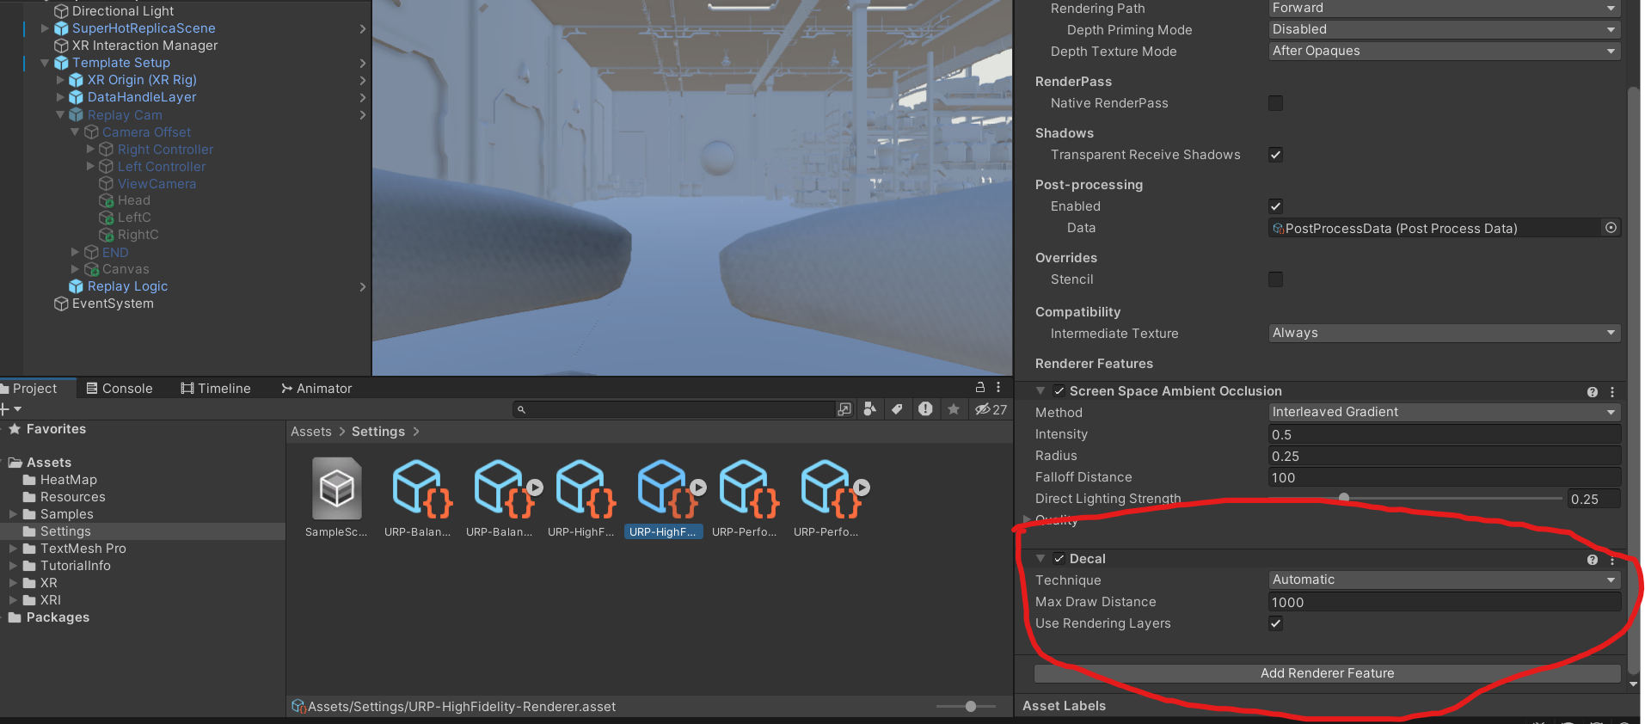

**Step 2 :** Create three new GameObjects under TemplateSetup> ReplayCam> CameraOffset.

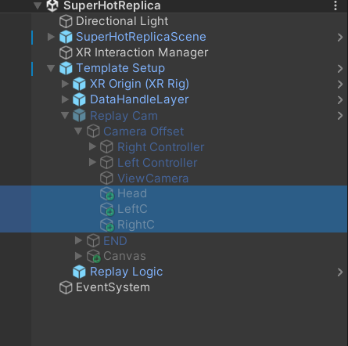

**Step 3 :** Add Texts under a Canvas inside TemplateSetup> ReplayCam, also add blank TMPs.

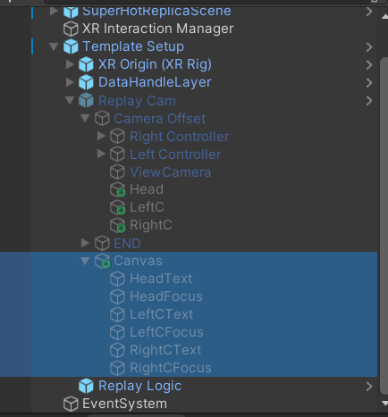

**Step 4 :** Assign the prefabs and the blank TMPs in the LoadCamData Script assigned to ViewCamera.

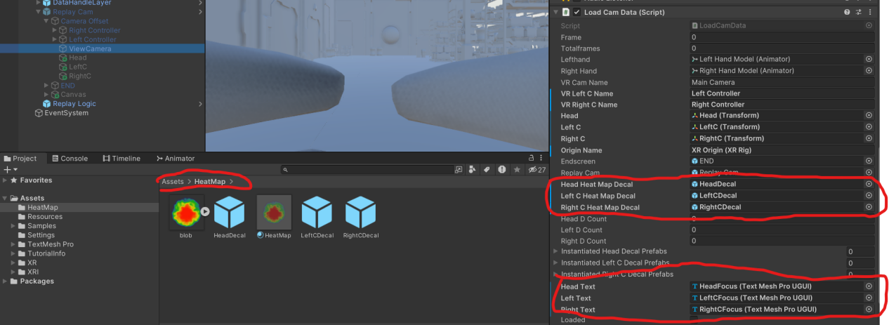

Just play the reply in the editor to See the HeatMaps.